Sensor Temperature Monitoring

docker start delivery-kafka
Creating assignment topic—
docker exec -it delivery-kafka /opt/kafka/bin/kafka-topics.sh --create --topic sensor-readings-lisha --partitions 2 --replication-factor 1 --bootstrap-server localhost:9092
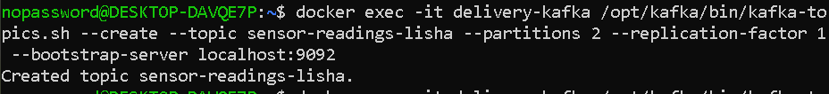

Verifying the topic—
docker exec -it delivery-kafka /opt/kafka/bin/kafka-topics.sh --describe --topic sensor-readings-lisha --bootstrap-server localhost:9092
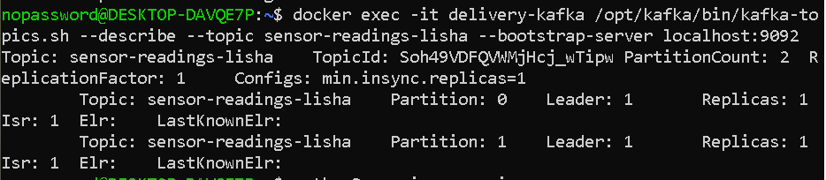

Creating the producer file—

from kafka import KafkaProducer
import json

producer = KafkaProducer(
bootstrap_servers="localhost:9092",
value_serializer=lambda x: json.dumps(x).encode("utf-8")
)

readings = [
{"sensor_id": "S101", "location": "Line-A", "temperature": 31.2},
{"sensor_id": "S102", "location": "Line-B", "temperature": 38.5},
{"sensor_id": "S103", "location": "Line-A", "temperature": 34.0},
{"sensor_id": "S104", "location": "Line-C", "temperature": 42.0},
{"sensor_id": "S105", "location": "Line-B", "temperature": 29.5},
{"sensor_id": "S106", "location": "Line-A", "temperature": 36.0},
{"sensor_id": "S107", "location": "Line-C", "temperature": 33.5},
{"sensor_id": "S108", "location": "Line-B", "temperature": 40.0},
{"sensor_id": "S109", "location": "Line-A", "temperature": 27.8},
{"sensor_id": "S110", "location": "Line-C", "temperature": 35.0}
]

for reading in readings:
producer.send("sensor-readings-lisha", reading)
print("Sent:", reading)

producer.flush()
producer.close()

print("All messages sent successfully!")

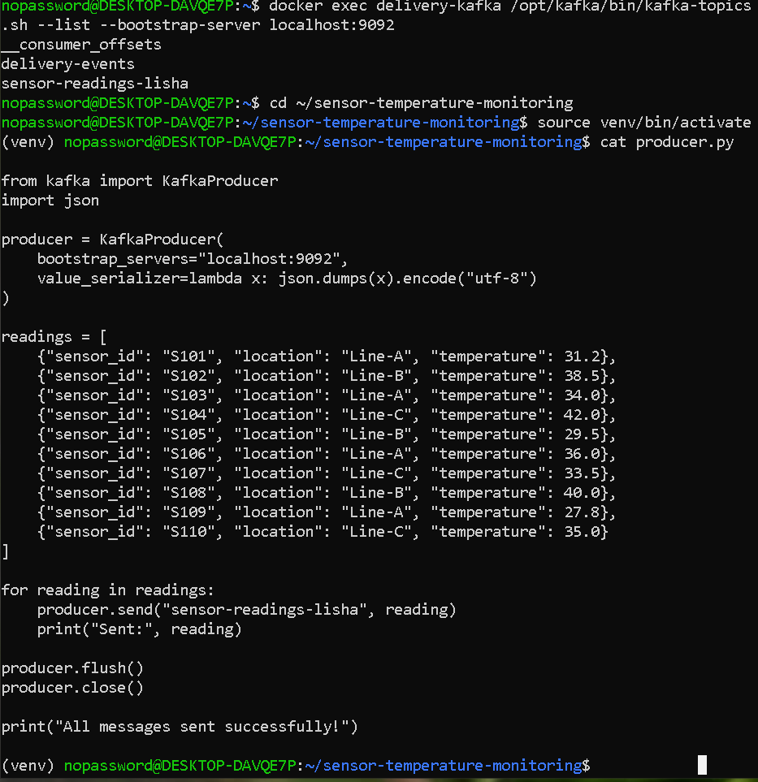

Creating the consumer file –
from kafka import KafkaConsumer
import json
def convert_message(message):
text = message.decode("utf-8")
return json.loads(text)
consumer = KafkaConsumer(
"sensor-readings-lisha",
bootstrap_servers="localhost:9092",
group_id="sensor-group-lisha",
auto_offset_reset="earliest",
value_deserializer=convert_message)
normal = 0
high = 0
invalid = 0
count = 0
for message in consumer:
reading = message.value
count = count + 1
try:
temperature = float(reading["temperature"])
if temperature < 35:
print(reading["sensor_id"], temperature, "NORMAL")
normal = normal + 1
else:
print(reading["sensor_id"], temperature, "HIGH")
high = high + 1
except (KeyError, ValueError, TypeError):
print("Invalid temperature:", reading)
invalid = invalid + 1
if count == 10:
break
consumer.close()
print("----- SUMMARY -----")
print("NORMAL:", normal)
print("HIGH:", high)
print("INVALID:", invalid)
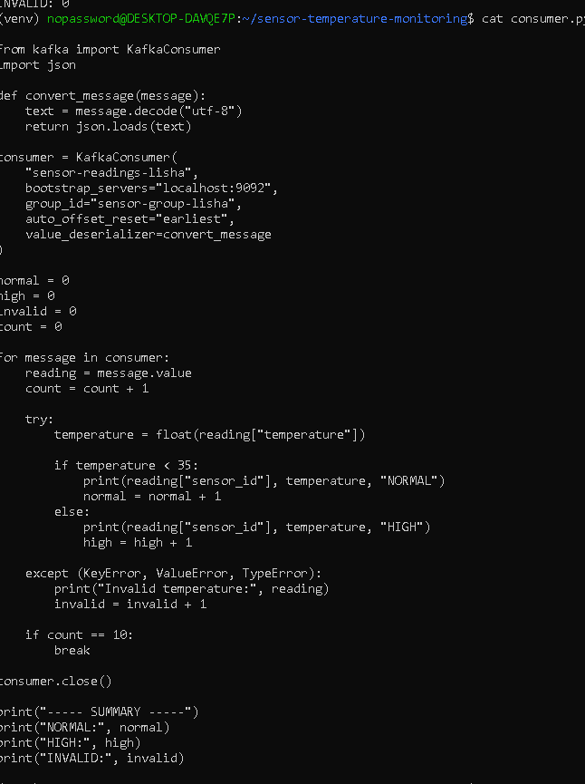

Output of producer and consumer—
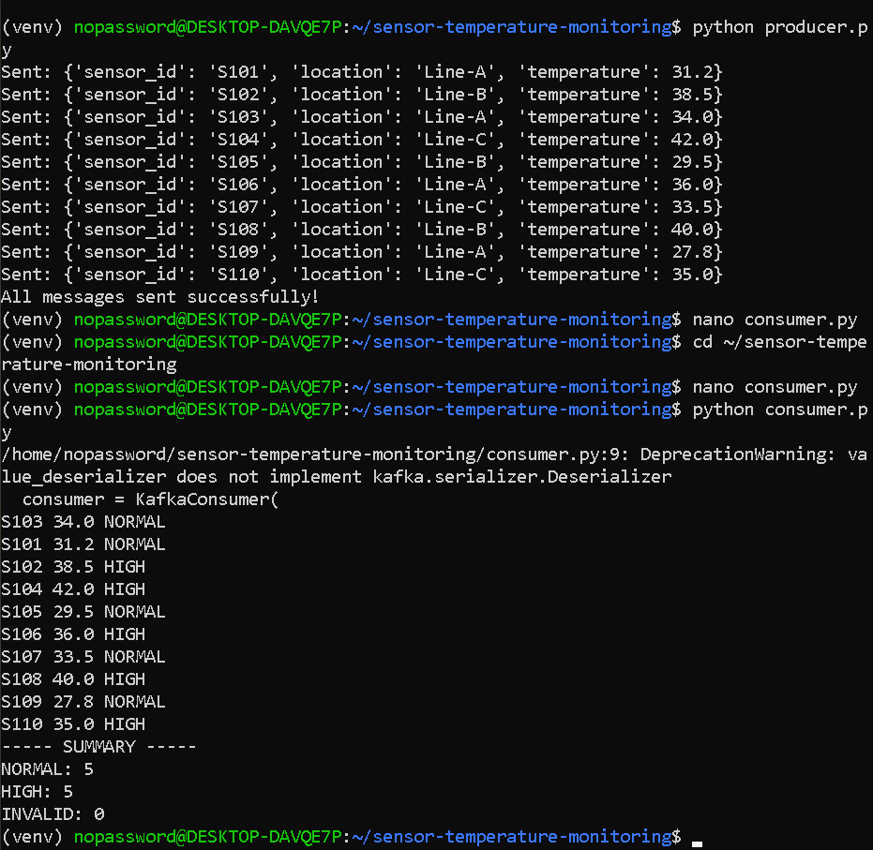

Testing an invalid temperature—
Adding invalid reading:
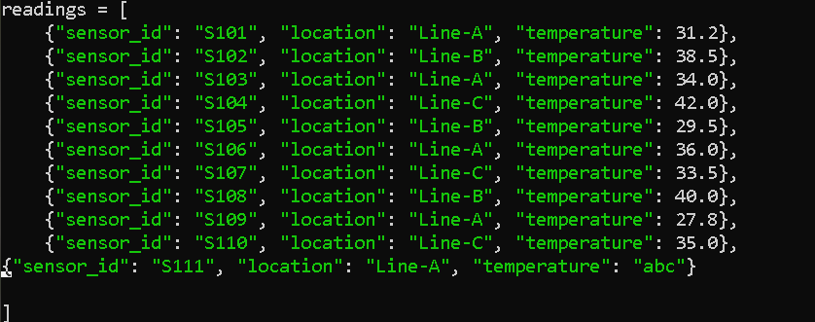

Invalid temperature handling—

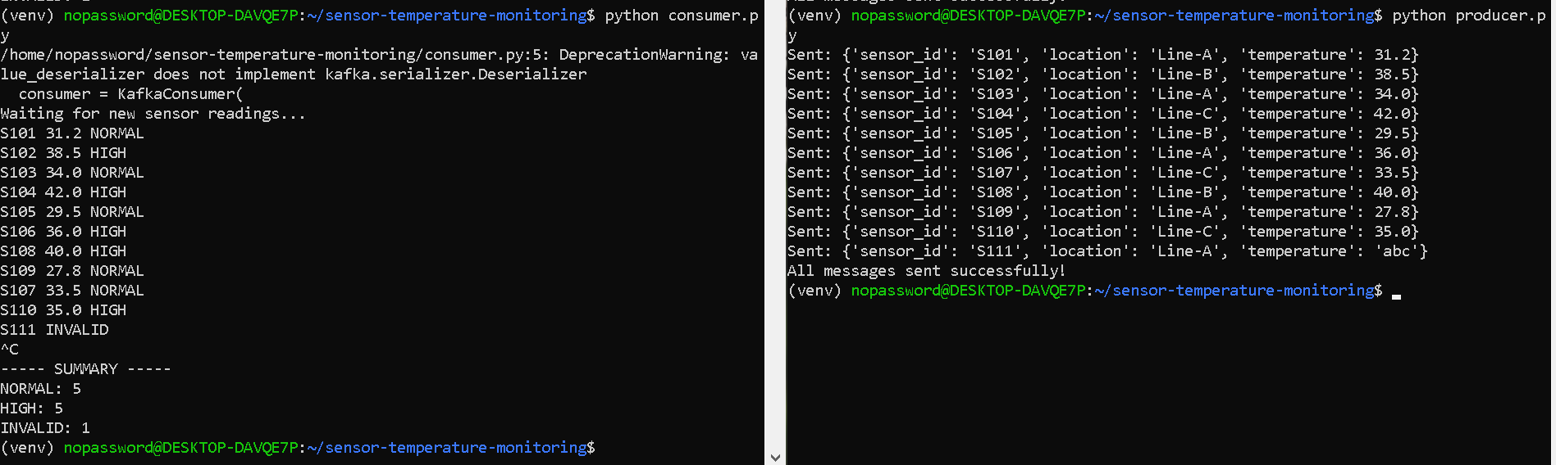

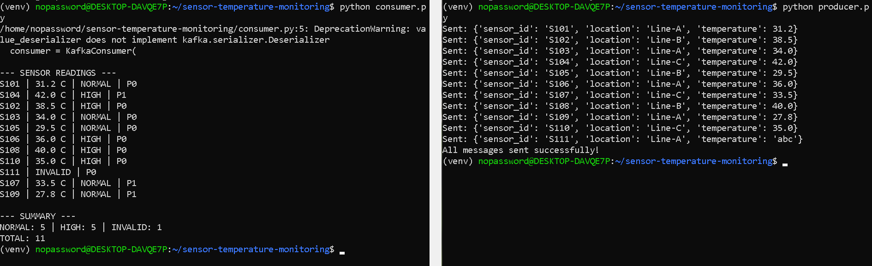

2 Consumer groups—
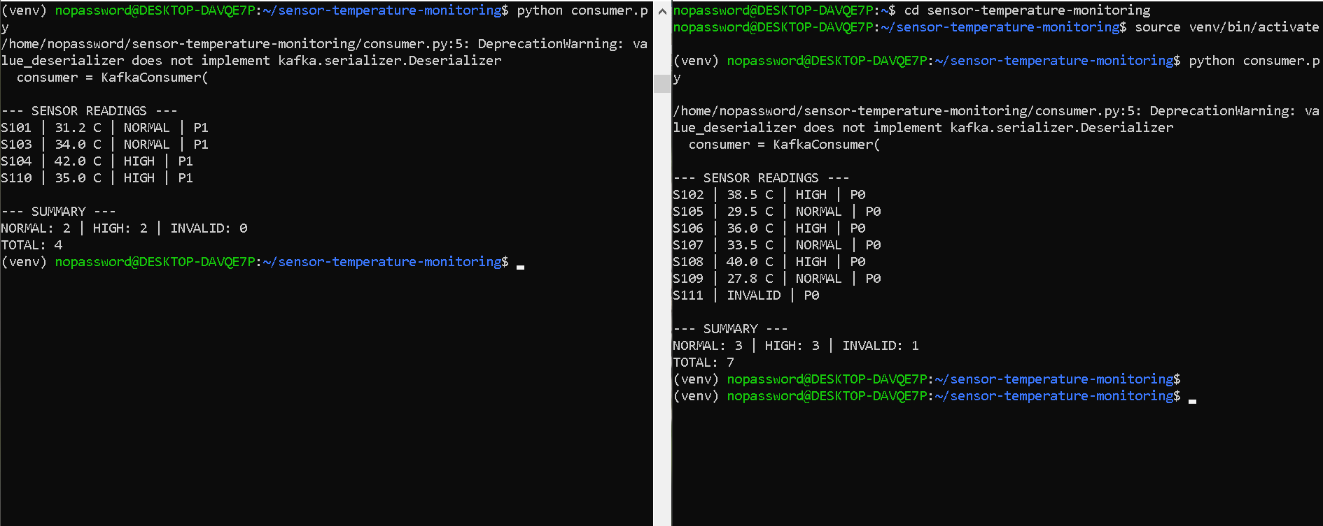

Updated consumer.py—

from kafka import KafkaConsumer
import json

consumer = KafkaConsumer(
"sensor-readings-lisha",
bootstrap_servers="localhost:9092",
group_id="sensor-group-lisha",
auto_offset_reset="latest",
value_deserializer=lambda x: json.loads(x.decode("utf-8")),
consumer_timeout_ms=30000
)

normal = 0
high = 0
invalid = 0
total = 0

print("\n--- SENSOR READINGS ---")

try:
for message in consumer:
reading = message.value
sensor_id = reading.get("sensor_id", "Unknown")

try:
temperature = float(reading["temperature"])

if temperature < 35:
print(f"{sensor_id} | {temperature} C | NORMAL | P{message.partition}")
normal += 1
else:
print(f"{sensor_id} | {temperature} C | HIGH | P{message.partition}")
high += 1

except (KeyError, ValueError, TypeError):
print(f"{sensor_id} | INVALID | P{message.partition}")
invalid += 1

total += 1

except KeyboardInterrupt:
print("\nConsumer stopped.")

finally:
consumer.close()

print("\n--- SUMMARY ---")
print(f"NORMAL: {normal} | HIGH: {high} | INVALID: {invalid}")
print(f"TOTAL: {total}")

